

PLACEBO

SYNOPSIS: PROJECT PRAGATI

STRATEGIC APPROACH TO ENHANCE

MFI OPERATIONS & HR PROCESSES

JAN 19 BATCH

MEET

THE

ELITE



RAVI CHANDRAN N

PRIYA KRISHNAN

MEENU

SETHURAMAN

DIVYA

LAKSHME A

 

SHIYAM SUNDAR TK

SUBASHREE BHASKARAN

**MENTOR**

SUDIPTO CHAUDHURI



**CONTENTS**

**Objective & Background**

**The Challenges we address…**

**Proposed Solution Space**

**About the Data**

**Tools to be used**

**In the Backup..**

**Microfinance Industry in India – An Overview**

**About Belstar Investment and Finance Pvt Ltd**

**Project Pragati Frame Work** [Synopsis Project Plan Link](https://docs.google.com/spreadsheets/d/1YpcWYNrB3ZPC4QWHGysAL4UfDgBSVSg1gQXQKX452xQ/edit?ts=5d39772a#gid=451848289)



Objective

The vision is to optimize the loan lending process, credit risk and HR processes at Belstar with the best use of business analytics and business intelligence. This data-driven approach will overcome the operation overheads, longer lead-time and poor delivery. This is a paradigm shift towards customer-centricity to reduce the loan turn-around time by 40%. The HR executives gain insights to improve future hiring decisions and strengthen HR policies to enlighten the workforce.

Background:

Belstar Investment and Finance Private Limited is a NBFC-MFI, a subsidiary of Muthoot Finance Limited. The MFI business is encountering challenges such as over-indebtedness customers, less reactive towards uncertainties, lack of product innovation and so on.

The **top problems** that build the foundation of analytics at Belstar:

|  |  |
| --- | --- |
| **Minimize Delinquent Customer sourcing thereby reduce credit risk** | Operation Analytics |
| **Optimize Loan turnaround time for competitiveness** | Operation Analytics |
| **People analytics to predict Attrition** | HR Analytics |
| **Devise Psychometric test for recruiting Credit Officers** | HR Analytics |
| **Build Job Evaluation model for customer-facing job cadres** | HR Analytics |

* Higher Loan Disbursement Turn Around Time (TAT) than the competition.
* Jumbled flow of operations with many stages involving tedious manual work
* Lose credit worthy customers due to error-prone manual process
* Repetitive follow-ups between Head-office and branches due to lack of established processes
* Adverse selection of borrowers as increasing transactional risks
* Infant attrition for customer-facing workforce effects in jittery in handling such uncertainty
* Very high re-hiring time of 45 days for customer-facing workforce
* No effective background check on credit officers
* Employee retention and promotion decisions are opinion based due to lack of job level grading

**The Challenges we address…**

**Proposed Solution Space**



|  |  |
| --- | --- |
| **Objective** | **Proposed Solution** |
| **Minimize Delinquent Customer sourcing thereby reduce credit risk** | * Random Forest or similar. * Logistic/LDA to determine highly significant independent variables. * Feedback to customer sourcing for informed quick decisions. |
| **Optimize Loan turnaround time for competitiveness** | * Identified Operation performance metrics. * Time Series Forecasting to forecast incoming loan application traffic. * Quantify metrics and identify bottlenecks. * Use Solver to optimize objective function at each stage of loan process. |
| **People analytics to predict Attrition** | * Linear regression to predict target based on significant independent variables * Logistic/LDA/SVM to predict Attrite or not. |
| **Devise Psychometric test for recruiting Credit Officers** | * Study value attributes expected from Belstar for Customer Sourcing cadre. * Devise psychometric questionnaire as an additional level in recruitment process of Credit Officers (Customer Sourcing Member). |
| **Build Job Evaluation model for customer-facing job cadres** | * Understand Point method, Hay method of Job evaluation. * Text analytics (NLP) to derive significant descriptor of 4 job roles. * Build model to devise a new job level grading system. |

**Attract & retaining employee** program

**Financial implications on the employees**

**Motivation & Rewards programs**

**HR strategy alignment with goals**

About the data

|  |  |  |
| --- | --- | --- |
| Objective | Data from Belstar | We intend to derive.. |
| Minimize Delinquent Customer sourcing thereby reduce credit risk | Loan demand data and loan instalment collection report  (Customer key identification such as AADHAR scrubbed) | On-Time Payment Customers & Delinquent Customers.  Feature Engineering to identify customers who are ‘Portfolio at risk’, ‘Non-Performing loan’, etc |
| Optimize Loan turnaround time for competitiveness | Operations – Loan processing – Workflow.  Day-Day traffic / Loan reconsideration reasons (will be shared on-demand) | Bottlenecks  Performance metrics can be measured |
| People analytics to predict Attrition | Attrition details with Exit interview information is available for 5 months. (Older data, available but not with relevant details) | Significant independent variables  Attrition prediction is possible. |
| Build Job Evaluation model for customer-facing job cadres | Job Description of 4 Job roles (covers ~ 50% of employees) | Text mining on Job description to derive Compensable Factors & relevant weights |



**DELIVARABLES FOR THE CAPSTONE PROJECT**

* CURRENT TRENDS AND FORECASTING:

Deliver future forecasts to help the organization plan and implement customer-centric strategies.

* OPTIMIZATION:

Better utilization of resources and improved collaboration between blue- and white-collar employees.

* FINANCIAL RISK ANALYSIS:

As MFI’s business model operates on mortgage free loans, risk analytics will help the organization identify right customers.

* ENVIRONMENTAL ANALYSIS:

To understand the position of BIFPL with in the market and plan future objectives based on understanding of the importance of each financial variable involved in the study.

* RESOUCE UTILIZATION:

Organization performance basis better utilization of Human Resources.



TOOLS TO BE USED:

* Tableau, Matplotlib, Seaborn for data visualization.
* Time Series Forecasting techniques like STL, Exponential Smoothing and ARIMA.
* Predictive models using machine learning techniques.
* Hypothesis testing, Poisson Distribution, Advanced Statistical concepts like ANOVA, MANOVA, linear regression & Association Rules.
* Linear Discriminant Analysis as Scoring model for predicting and differentiation.
* Programming languages – R, Python & SQL.
* Google Cloud Platform for virtual storage and processing of data.



BACKUP

Project PRAGATI Framework



Microfinance Industry in India – An Overview

The Indian Microfinance Sector has witnessed a phenomenal growth over the past 19 years. The number of institutions providing microfinance services has gone up from a few to several hundreds. The quantum of credit made available to the poor and financially backward people has reached `68,789 crores and number of clients benefitted, crossed 35 million as of March 2018. The SHG bank linkage program has equally grown to touch the lives of individuals through SHGs (Self Help Group) with an outstanding loan portfolio of `75,598 crores.

The Government of India and the Reserve Bank of India jointly created conducive policy and regulatory framework for Microfinance Institutions (MFIs) to operate in the country. This has provided necessary legitimacy and impetus to the sector. MFIs in general comply with the regulations, take care of client protection issues, and adhere to the Industry Code of Conduct. These factors go a long way in infusing confidence among all the stakeholders to be the investible destination.

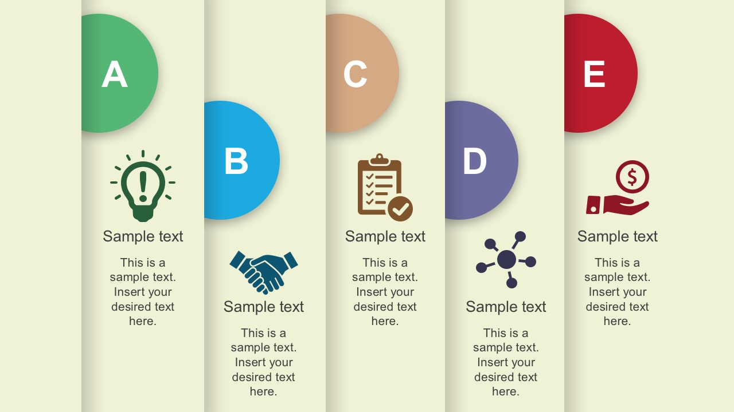

BELSTAR INVESTMENT AND FINANCE PRIVATE LIMITED (BIFPL)

Belstar was acquired by Hand in Hand group in September 2008 to provide scalable microfinance services to entrepreneurs nurtured by the Hand in Hand India (HIH) Self Help Group (SHG) program. It aims to provide financial assistance to more than 0.3 million borrowers.

The MFI business in the world today is encountering an economic unpredictability, disruptive technology, and red ocean fierce competition.

In such an environment, ongoing ways of achieving a competitive advantage such as increased economics of scale and improved capital investment are no longer adequate. The ability of a company to address the new realities, adaptation to the changing conditions, and willingness to deliver bold transformation is significant, to gain market leadership and Increased bottom-line. This infers that more comprehensive and **PERIODIC PREDICTION** programs are imperative to drive towards strategic goals. The case study will be on **OPERATIONS, HR & FINANCIAL ANALYTICS** and it is elucidated in detail in following slides.

SUCCESS EVALUATION

OPERATIONS & RESOURCE UTLIZATION ANALYSIS

FINANCIAL ANALYSIS

OPTIMIZATION

& ENVIRONMENTAL ANALYSIS

CURRENT TRENDS & FORECASTING

PROJECT PRAGATI



PROJECT PRAGATI: A BRIEF INTRODUCTION TO PARAMETERS & CONCEPTS UNDER STUDY

CURRENT TRENDS & FORECASTING:

Supply, Demand and Potential of the locations operated, Forecasting Demand and fulfillment curve, Forecasting seasonality requirements in tandem with respect to borrowers and their respective locations, Upgrading existing price and promotion packages basis the forecast.

OPTIMIZATION:

Borrower’s requirement, their utility & repayment patterns with a given level of income or money to understand customer behavior with help of cluster analysis., Free access to fair and correct information on the process, Complaint reduction.

ENVIRONMENT ANALYSIS:

Elevate BELSTAR in Competitive Market Ladder, Knowing Potential Investment Areas, MFI Products or Services.

FINANCIAL RISK ANALYSIS:

**Internal:** Transaction information- value, time of joining, IDs & remittance information. Credit line & Risk history, Accounts & Balances of portfolios, Fees, benefits, waivers and applications history, Demographic and location v/s profitability, campaign responses etc.

**External:** Life events- Marital status, education information, occupation information vehicle ownership, Utility usage (phone, electricity bill etc,) Risk and collection history.

RESOURCE UTILIZATION:

Predictive model building to analyze Infant attrition (0-6 Months) in the work horse category of employees.

Statistical Modelling of Psychometric assessment for quality hiring of work horse cadets in employee chain.



**BUSINESS PLAN REMODELLING: FOR MINIMIZING TAT FOR LOAN DISBURSEMENT CYCLE TIME.**

1. Customer request for a loan.

2. Identify customer needs.

3. Data collection for the prerequisites.

4. Automated Customer bureau checks for precision.

5. Automated calculation of loans and EMI.

6. Sanction of loans with automated checks.

7. Communicating disbursements to requestor.

8. Data Update

8

7

6

5

4

3

2

1

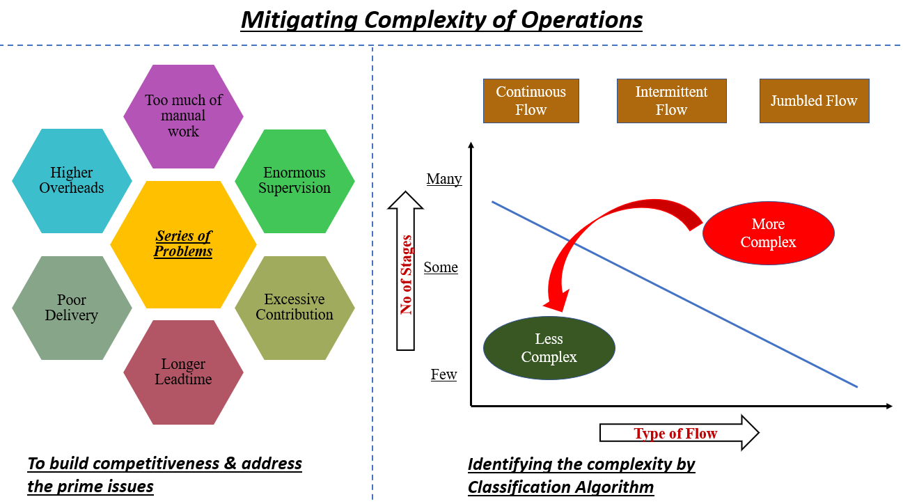

MINIMIZING THE COMPLEXITY OF THE PROCESS BY ALTERING THE EASE OF FLOW



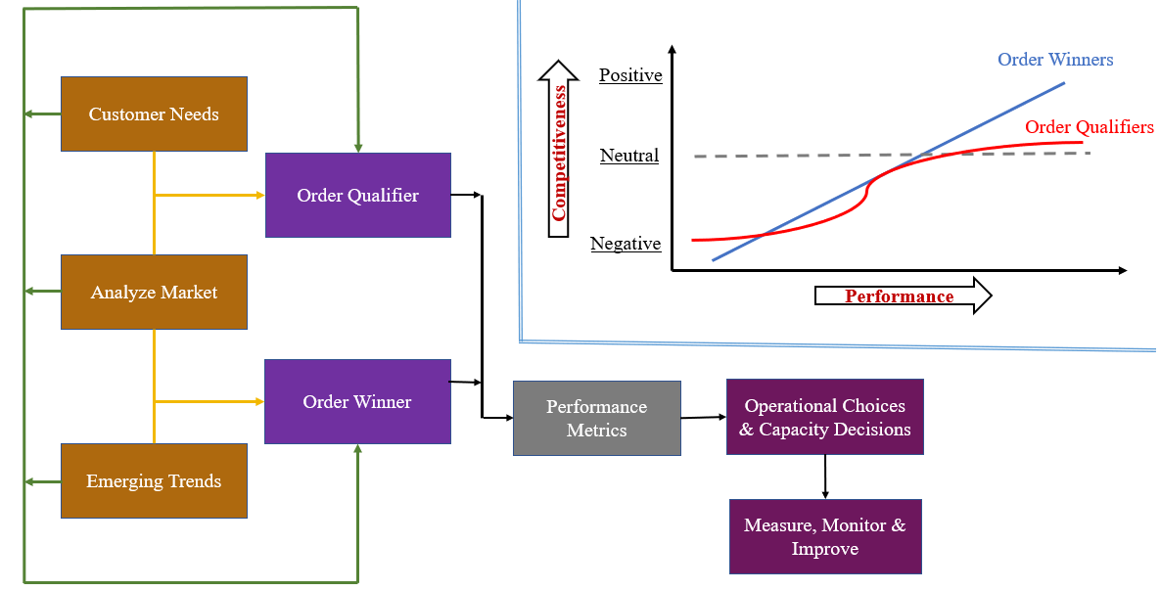

**CREATING RELEVANT LOAN BUNDLES TO INDENTIFY ORDER QUALIFIERS & ORDER WINNERS**



1

2

3

Emerging Challenges:

Growing customer expectations: (Develop Capabilities)

Technology Enhancement: Analytics

Environment Concerns: Sustainable Operating Conditions.

Prioritize Performance Metrics:

Relate operations with retention of customers

Acquire capabilities

Promote learning

Have simplified metrics

Limiting to Two Sets of Metrics:

Order Qualifiers

Order Winning attributes

OPERATIONS EXCELLENCE MAP



Flexibility:

Number of models

Number of variations.

Innovation:

Number of new Models

Patents

Learning:

Training Time

Suggestions per employee

Improvement:

Reduction of process (Redundant)

FOCUSING ON PERFORMANCE MEASURES

Quality:

Loans per month

Defects per batch opportunities

Quality cost

First pass yield

Cost:

Cost of identifying customers

Sourcing & Screening cost

Investment in man power

Delivery:

Order fulfillment time

On-time delivery index

Schedule adherence

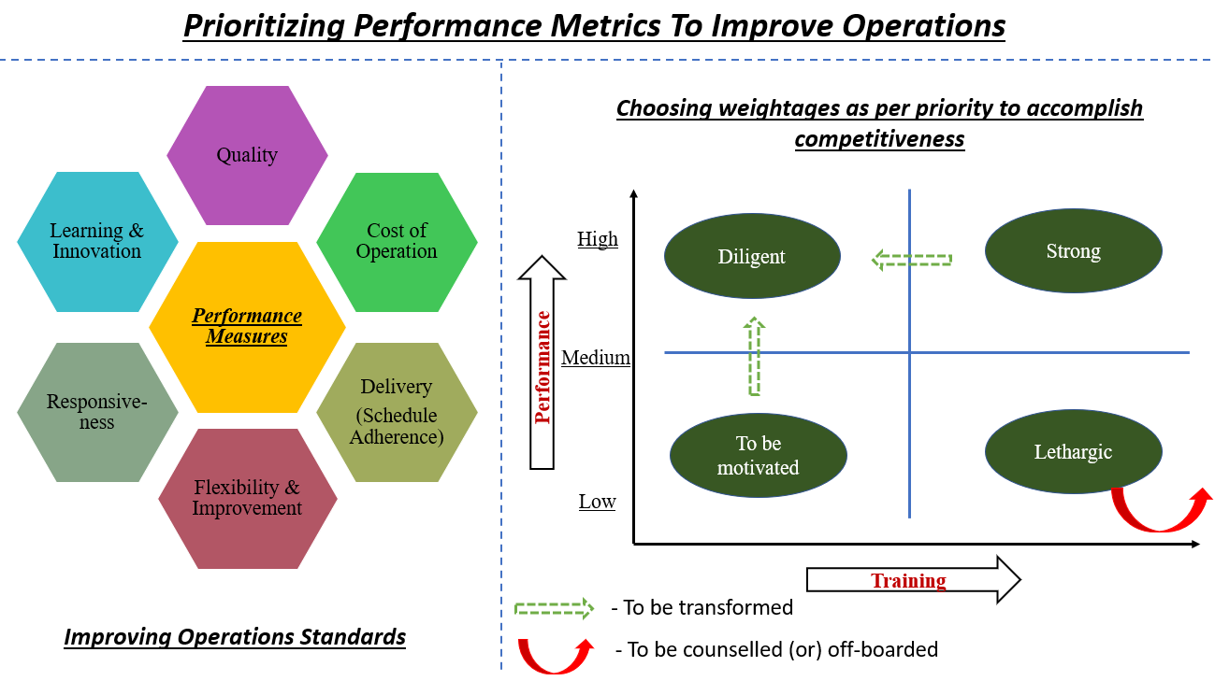

TO OBTAIN THE RELATION BETWEEN THE PERFORMANCE METRICS AND THE CURRENT PROCESS & DELIVERING INSIGHTS

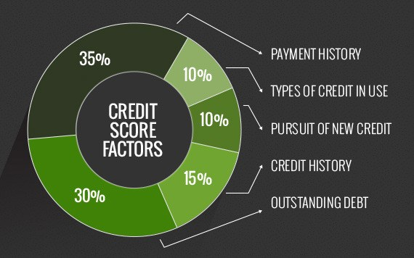

CREDIT RISK ANALYSIS

For credit risk analysis other factors are also to be taken into consideration:

* The utility of the funds on the monthly basis (ex- gas purchase, mobile bills, electricity bills etc to understand the capacity of the requestor)
* Any other source of borrowing history (the Cluster manager’s job)
* The environmental factors like monsoon and other seasonality dependent income variables (festival etc).
* The exodus of new generation from rural to urban increases the share of the wallet.
* Education, vocational training, skills etc



**PROJECT DELIVERABLES:**

* **To obtain performance metrics for the employees of BELSTAR.**
* **To Predict attrition of Cluster Managers.**
* **To design a psychometric test for employee, analyze various behaviors, traits and attitudes.**

**Managing human resources to have a delightful experience impact is the call of the era. Data science gives a profound insight to a business strategy for creating and maximizing competitive advantages to accomplish the organization's mission.**

* **Talent acquisition**
* **Performance management**
* **Training and development**
* **Employee retention and engagement**
* **Employment law compliance**
* **Compensation and benefits**

**Communication, documentations, timesheets, interaction schemas**

**Attributes to be studied**

**HR STUDY**

**Data Source**

**Past data on performance evaluation**

**Past data on Employee & Customer satisfaction**

**Job Description**

**(Role charter)**

**Employee profile (experience and skill set)**

**Attract & retaining employee** program

**Financial implications on the employees**

**Motivation & Rewards programs**

**HR strategy alignment with goals**